Instructions for Making Knowledge Ratings

These questions are about work-related areas of knowledge. Knowledge areas are sets of facts and principles needed to address problems and issues that are part of a job. You will be asked about a series of different areas of knowledge and how they relate to your current job - that is, the job you hold now.

Each knowledge area in this questionnaire is named and defined.

For example:
Economics and Accounting | Knowledge of economic and accounting principles and practices, the financial markets, banking, and the analysis and reporting of financial data.
You are then asked two questions about each knowledge area:
A

How important is the knowledge area to the performance of your current job?

For example:

How important is ECONOMICS AND ACCOUNTING knowledge to the performance of your current job?
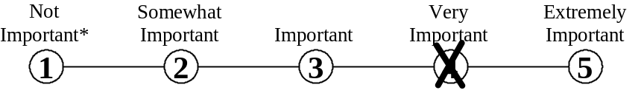

Mark your answer by putting an X through the number that represents your answer.
Do not mark on the line between the numbers.

*If you rate the knowledge area as Not Important to the performance of your job, mark the one
[ ] then skip over question B and proceed to the next knowledge area.
B

What level of the knowledge is needed to perform your current job?

To help you understand what we mean by level, we provide you with examples of job-related activities at different levels. For example:

What level of ECONOMICS AND ACCOUNTING knowledge is needed to perform your current job?
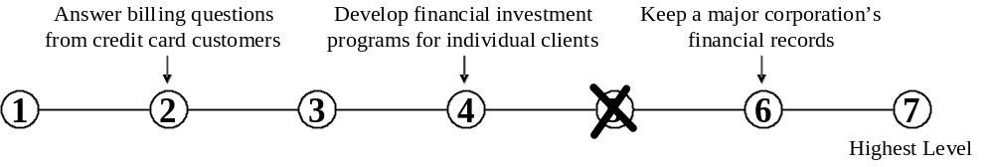

Mark your answer by putting an X through the number that represents your answer.
Do not mark on the line between the numbers.
1. Administration and Management | Knowledge of business and management principles involved in strategic planning, resource allocation, human resources modeling, leadership technique, production methods, and coordination of people and resources.
A. How important is ADMINISTRATION AND MANAGEMENT knowledge to the performance of your current job?

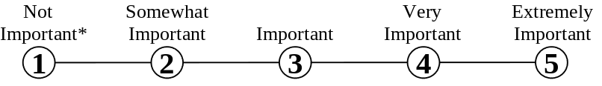

* If you marked Not Important, skip LEVEL below and go on to the next knowledge area.

B. What level of ADMINISTRATION AND MANAGEMENT knowledge is needed to perform your current job?

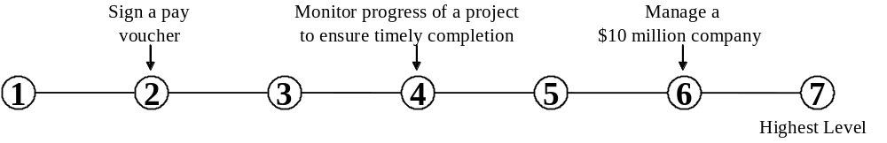

2. Clerical | Knowledge of administrative and clerical procedures and systems such as word processing, managing files and records, stenography and transcription, designing forms, and other office procedures and terminology.
A. How important is CLERICAL knowledge to the performance of your current job?

* If you marked Not Important, skip LEVEL below and go on to the next knowledge area.

B. What level of CLERICAL knowledge is needed to perform your current job?

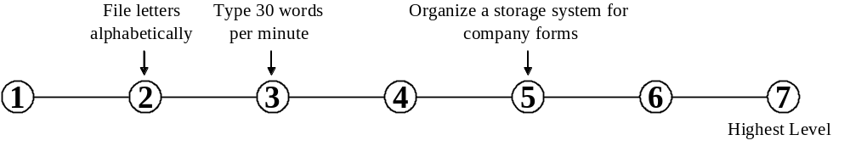

3. Economics and Accounting | Knowledge of economic and accounting principles and practices, the financial markets, banking, and the analysis and reporting of financial data.
A. How important is ECONOMICS AND ACCOUNTING knowledge to the performance of your current job?

* If you marked Not Important, skip LEVEL below and go on to the next knowledge area.

B. What level of ECONOMICS AND ACCOUNTING knowledge is needed to perform your current job?

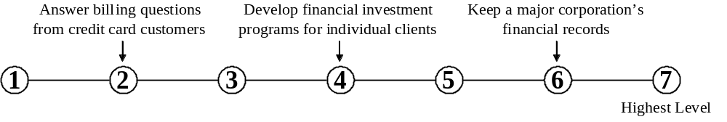

4. Sales and Marketing | Knowledge of principles and methods for showing, promoting, and selling products or services. This includes marketing strategy and tactics, product demonstration, sales techniques, and sales control systems.
A. How important is SALES AND MARKETING knowledge to the performance of your current job?

* If you marked Not Important, skip LEVEL below and go on to the next knowledge area.

B. What level of SALES AND MARKETING knowledge is needed to perform your current job?

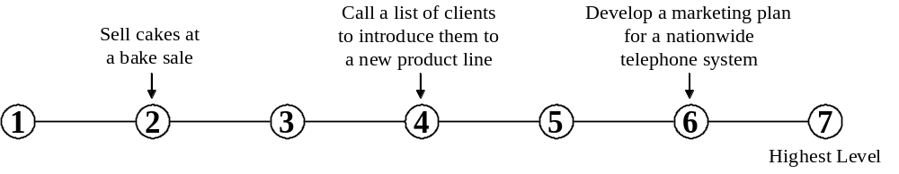

5. Customer and Personal Service | Knowledge of principles and processes for providing customer and personal services. This includes customer needs assessment, meeting quality standards for services, and evaluation of customer satisfaction.
A. How important is CUSTOMER AND PERSONAL SERVICE knowledge to the performance of your current job?

* If you marked Not Important, skip LEVEL below and go on to the next knowledge area.

B. What level of CUSTOMER AND PERSONAL SERVICE knowledge is needed to perform your current job?
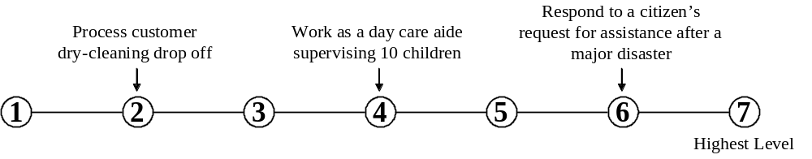

6. Personnel and Human Resources | Knowledge of principles and procedures for personnel recruitment, selection, training, compensation and benefits, labor relations and negotiation, and personnel information systems.
A. How important is knowledge of PERSONNEL AND HUMAN RESOURCES to the performance of your current job?

* If you marked Not Important, skip LEVEL below and go on to the next knowledge area.

B. What level of PERSONNEL AND HUMAN RESOURCES knowledge is needed to perform your current job?
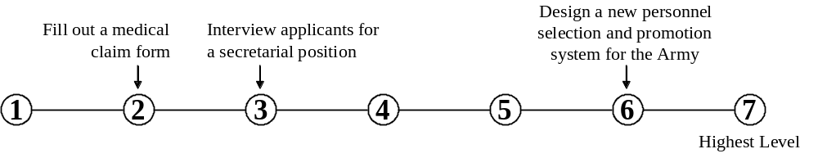

7. Production and Processing | Knowledge of raw materials, production processes, quality control, costs, and other techniques for maximizing the effective manufacture and distribution of goods.
A. How important is knowledge of PRODUCTION AND PROCESSING to the performance of your current job?

* If you marked Not Important, skip LEVEL below and go on to the next knowledge area.

B. What level of PRODUCTION AND PROCESSING knowledge is needed to perform your current job?
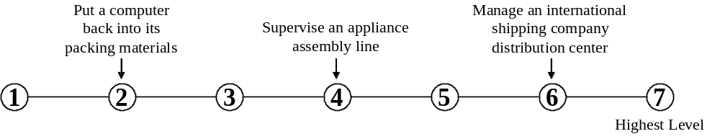

8. Food Production | Knowledge of techniques and equipment for planting, growing, and harvesting food products (both plant and animal) for consumption, including storage/ handling techniques.
A. How important is knowledge of FOOD PRODUCTION to the performance of your current job?

* If you marked Not Important, skip LEVEL below and go on to the next knowledge area.

B. What level of FOOD PRODUCTION knowledge is needed to perform your current job?
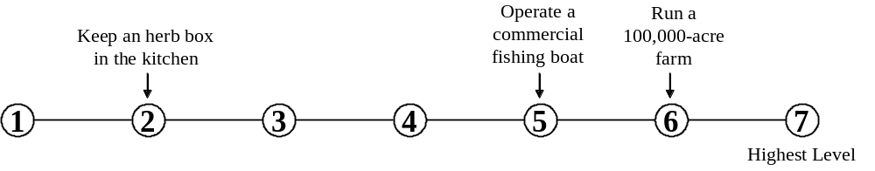

9. Computers and Electronics | Knowledge of circuit boards, processors, chips, electronic equipment, and computer hardware and software, including applications and programming.
A. How important is knowledge of COMPUTERS AND ELECTRONICS to the performance of your current job?

* If you marked Not Important, skip LEVEL below and go on to the next knowledge area.

B. What level of knowledge of COMPUTERS AND ELECTRONICS is needed to perform your current job?
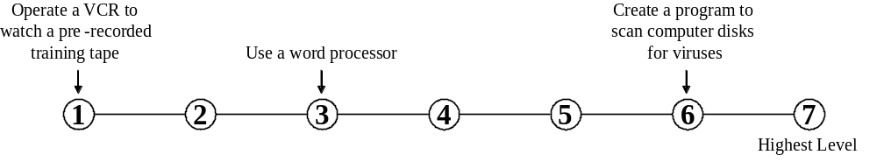

10. Engineering and Technology | Knowledge of the practical application of engineering science and technology. This includes applying principles, techniques, procedures, and equipment to the design and production of various goods and services.
A. How important is knowledge of ENGINEERING AND TECHNOLOGY to the performance of your current job?

* If you marked Not Important, skip LEVEL below and go on to the next knowledge area.

B. What level of knowledge of ENGINEERING AND TECHNOLOGY is needed to perform your current job?
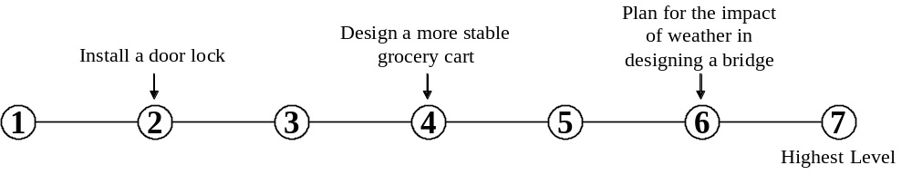

11. Design | Knowledge of design techniques, tools, and principles involved in production of precision technical plans, blueprints, drawings, and models.
A. How important is knowledge of DESIGN to the performance of your current job?

* If you marked Not Important, skip LEVEL below and go on to the next knowledge area.

B. What level of knowledge of DESIGN is needed to perform your current job?

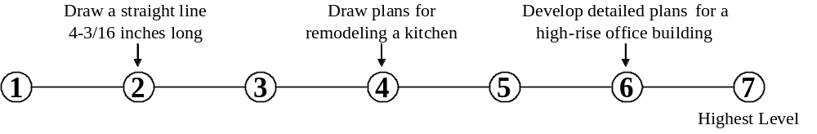

12. Building and Construction | Knowledge of materials, methods, and the tools involved in the construction or repair of houses, buildings, or other structures such as highways and roads.
A. How important is knowledge of BUILDING AND CONSTRUCTION to the performance of your current job?

* If you marked Not Important, skip LEVEL below and go on to the next knowledge area.

B. What level of BUILDING AND CONSTRUCTION knowledge is needed to perform your current job?

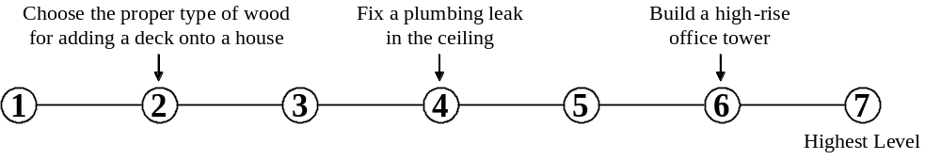

13. Mechanical | Knowledge of machines and tools, including their designs, uses, repair, and maintenance.
A. How important is MECHANICAL knowledge to the performance of your current job?

* If you marked Not Important, skip LEVEL below and go on to the next knowledge area.

B. What level of MECHANICAL knowledge is needed to perform your current job?

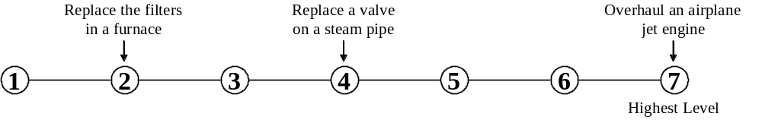

14. Mathematics | Knowledge of arithmetic, algebra, geometry, calculus, statistics, and their applications.
A. How important is knowledge of MATHEMATICS to the performance of your current job?

* If you marked Not Important, skip LEVEL below and go on to the next knowledge area.

B. What level of knowledge of MATHEMATICS is needed to perform your current job?

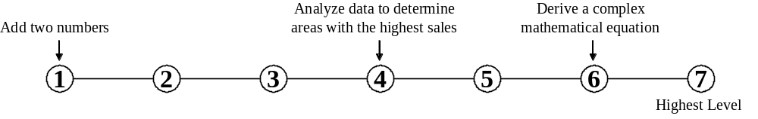

15. Physics | Knowledge and prediction of physical principles, laws, their interrelationships, and applications to understanding fluid, material, and atmospheric dynamics, and mechanical, electrical, atomic and sub-atomic structures and processes.
A. How important is knowledge of PHYSICS to the performance of your current job?

* If you marked Not Important, skip LEVEL below and go on to the next knowledge area.

B. What level of PHYSICS knowledge is needed to perform your current job?

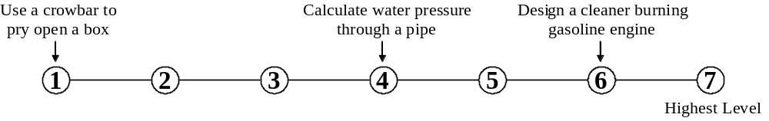

16. Chemistry | Knowledge of the chemical composition, structure, and properties of substances and of the chemical processes and transformations that they undergo. This includes uses of chemicals and their interactions, danger signs, production techniques, and disposal methods.
A. How important is knowledge of CHEMISTRY to the performance of your current job?

* If you marked Not Important, skip LEVEL below and go on to the next knowledge area.

B. What level of CHEMISTRY knowledge is needed to perform your current job?

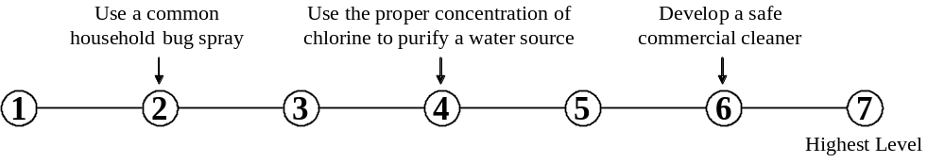

17. Biology | Knowledge of plant and animal organisms and their tissues, cells, functions, interdependencies, and interactions with each other and the environment.
A. How important is knowledge of BIOLOGY to the performance of your current job?

* If you marked Not Important, skip LEVEL below and go on to the next knowledge area.

B. What level of BIOLOGY knowledge is needed to perform your current job?
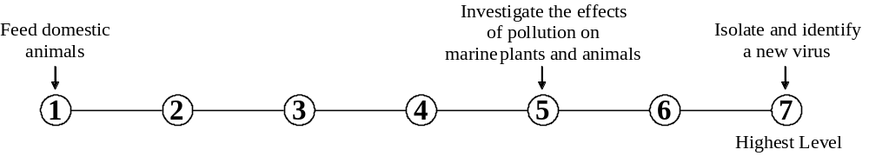

18. Psychology | Knowledge of human behavior and performance; individual differences in ability, personality, and interests; learning and motivation; psychological research methods; and the assessment and treatment of behavioral and affective disorders.
A. How important is knowledge of PSYCHOLOGY to the performance of your current job?

* If you marked Not Important, skip LEVEL below and go on to the next knowledge area.

B. What level of PSYCHOLOGY knowledge is needed to perform your current job?

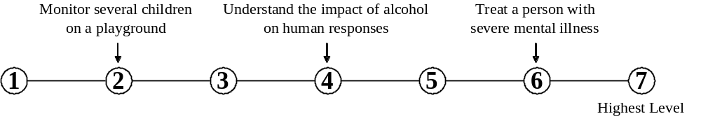

19. Sociology and Anthropology | Knowledge of group behavior and dynamics, societal trends and influences, human migrations, ethnicity, cultures, and their history and origins.
A. How important is knowledge of SOCIOLOGY AND ANTHROPOLOGY to the performance of your current job?

* If you marked Not Important, skip LEVEL below and go on to the next knowledge area.

B. What level of knowledge of SOCIOLOGY AND ANTHROPOLOGY is needed to perform your current job?
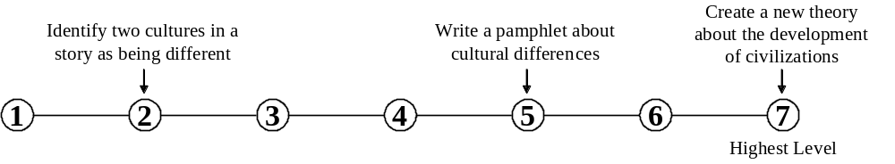

20. Geography | Knowledge of principles and methods for describing the features of land, sea, and air masses, including their physical characteristics, locations, interrelationships, and distribution of plant, animal, and human life.
A. How important is knowledge of GEOGRAPHY to the performance of your current job?

* If you marked Not Important, skip LEVEL below and go on to the next knowledge area.

B. What level of knowledge of GEOGRAPHY is needed to perform your current job?

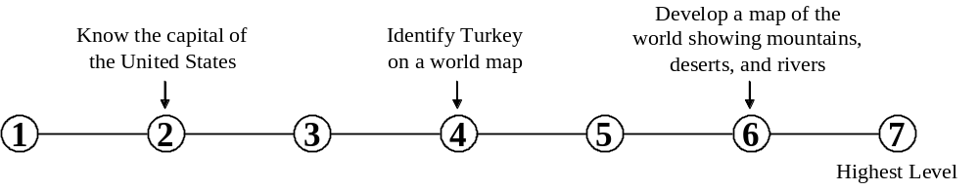

21. Medicine and Dentistry | Knowledge of the information and techniques needed to diagnose and treat human injuries, diseases, and deformities. This includes symptoms, treatment alternatives, drug properties and interactions, and preventive health-care measures.
A. How important is knowledge of MEDICINE AND DENTISTRY to the performance of your current job?

* If you marked Not Important, skip LEVEL below and go on to the next knowledge area.

B. What level of MEDICINE AND DENTISTRY knowledge is needed to perform your current job?

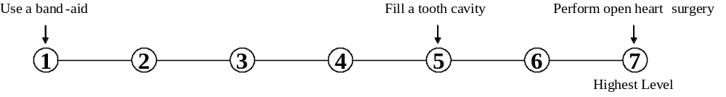

22. Therapy and Counseling | Knowledge of principles, methods, and procedures for diagnosis, treatment, and rehabilitation of physical and mental dysfunctions, and for career counseling and guidance.
A. How important is knowledge of THERAPY AND COUNSELING to the performance of your current job?

* If you marked Not Important, skip LEVEL below and go on to the next knowledge area.

B. What level of THERAPY AND COUNSELING knowledge is needed to perform your current job?

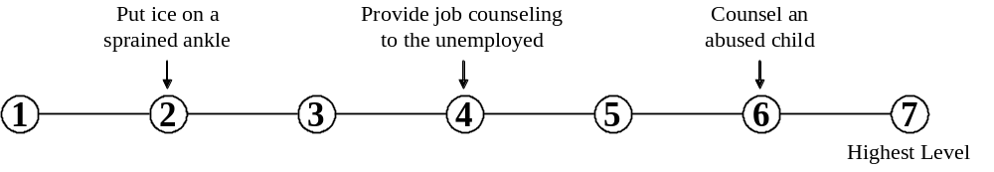

23. Education and Training | Knowledge of principles and methods for curriculum and training design, teaching and instruction for individuals and groups, and the measurement of training effects.
A. How important is knowledge of EDUCATION AND TRAINING to the performance of your current job?

* If you marked Not Important, skip LEVEL below and go on to the next knowledge area.

B. What level of EDUCATION AND TRAINING knowledge is needed to perform your current job?

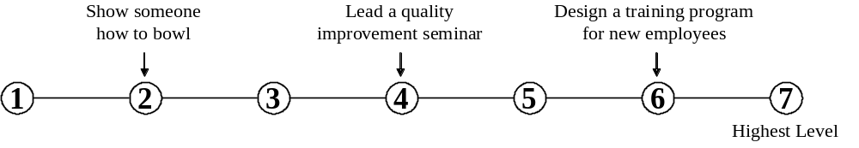

24. English Language | Knowledge of the structure and content of the English language including the meaning and spelling of words, rules of composition, and grammar.
A. How important is knowledge of the ENGLISH LANGUAGE to the performance of your current job?

* If you marked Not Important, skip LEVEL below and go on to the next knowledge area.

B. What level of ENGLISH LANGUAGE knowledge is needed to perform your current job?

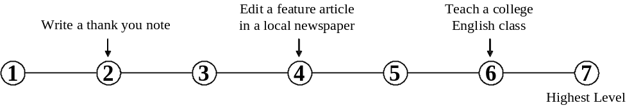

25. Foreign Language | Knowledge of the structure and content of a foreign (non-English) language including the meaning and spelling of words, rules of composition and grammar, and pronunciation.
A. How important is knowledge of a FOREIGN LANGUAGE to the performance of your current job?

* If you marked Not Important, skip LEVEL below and go on to the next knowledge area.

B. What level of FOREIGN LANGUAGE knowledge is needed to perform your current job?

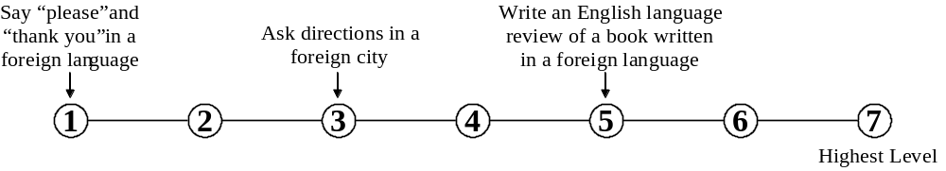

26. Fine Arts | Knowledge of the theory and techniques required to compose, produce, and perform works of music, dance, visual arts, drama, and sculpture.
A. How important is knowledge of FINE ARTS to the performance of your current job?

* If you marked Not Important, skip LEVEL below and go on to the next knowledge area.

B. What level of FINE ARTS knowledge is needed to perform your current job?

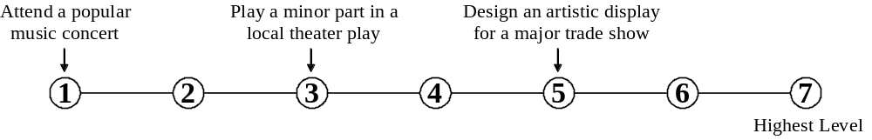

27. History and Archeology | Knowledge of historical events and their causes, indicators, and effects on civilizations and cultures.
A. How important is knowledge of HISTORY AND ARCHEOLOGY to the performance of your current job?

* If you marked Not Important, skip LEVEL below and go on to the next knowledge area.

B. What level of knowledge of HISTORY AND ARCHEOLOGY is needed to perform your current job?
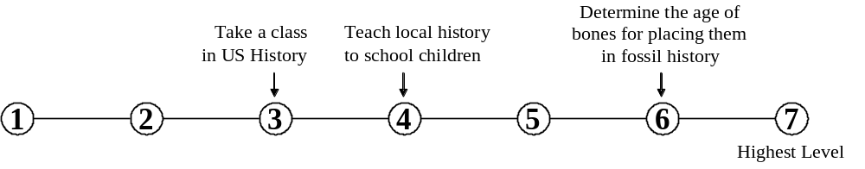

28. Philosophy and Theology | Knowledge of different philosophical systems and religions. This includes their basic principles, values, ethics, ways of thinking, customs, practices, and their impact on human culture.
A. How important is knowledge of PHILOSOPHY AND THEOLOGY to the performance of your current job?

* If you marked Not Important, skip LEVEL below and go on to the next knowledge area.

B. What level of knowledge of PHILOSOPHY AND THEOLOGY is needed to perform your current job?
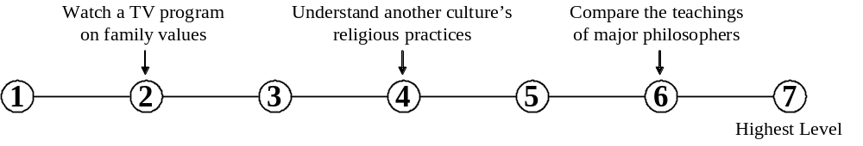

29. Public Safety and Security | Knowledge of relevant equipment, policies, procedures, and strategies to promote effective local, state, or national security operations for the protection of people, data, property, and institutions.
A. How important is PUBLIC SAFETY AND SECURITY knowledge to the performance of your current job?

* If you marked Not Important, skip LEVEL below and go on to the next knowledge area.

B. What level of PUBLIC SAFETY AND SECURITY knowledge is needed to perform your current job?

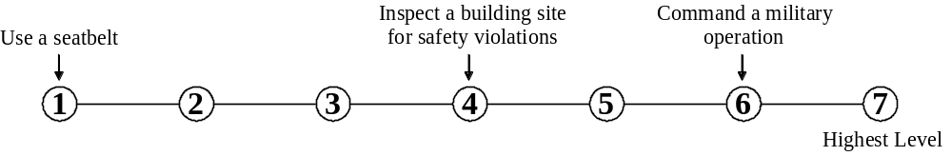

30. Law and Government | Knowledge of laws, legal codes, court procedures, precedents, government regulations, executive orders, agency rules, and the democratic political process.
A. How important is knowledge of LAW AND GOVERNMENT to the performance of your current job?

* If you marked Not Important, skip LEVEL below and go on to the next knowledge area.

B. What level of knowledge of LAW AND GOVERNMENT is needed to perform your current job?
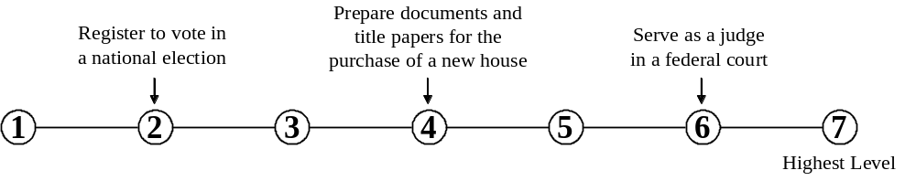

31. Telecommunications | Knowledge of transmission, broadcasting, switching, control, and operation of telecommunications systems.
A. How important is knowledge of TELECOMMUNICATIONS to the performance of your current job?

* If you marked Not Important, skip LEVEL below and go on to the next knowledge area.

B. What level of TELECOMMUNICATIONS knowledge is needed to perform your current job?

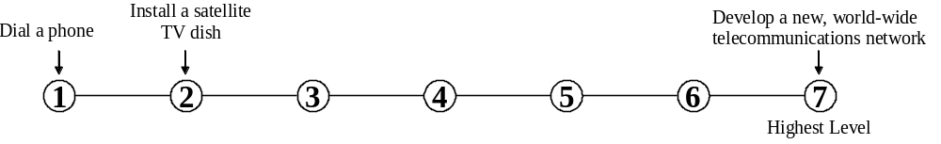

32. Communications and Media | Knowledge of media production, communication, and dissemination techniques and methods. This includes alternative ways to inform and entertain via written, oral, and visual media.
A. How important is knowledge of COMMUNICATIONS AND MEDIA to the performance of your current job?

* If you marked Not Important, skip LEVEL below and go on to the next knowledge area.

B. What level of COMMUNICATIONS AND MEDIA knowledge is needed to perform your current job?
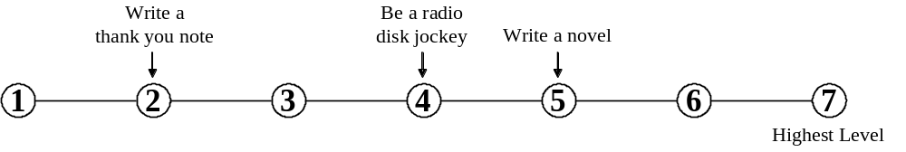

33. Transportation | Knowledge of principles and methods for moving people or goods by air, rail, sea, or road, including the relative costs and benefits.
A. How important is knowledge of TRANSPORTATION to the performance of your current job?

* If you marked Not Important, skip LEVEL below and go on to the next knowledge area.

B. What level of TRANSPORTATION knowledge is needed to perform your current job?
